**MOVIE DATASET SOLUTION**

**1.Load The File**

**movies = LOAD '/home/cloudera/Desktop/movies.txt' USING PigStorage(',') as (id:int,name:chararray,year:int,rating:int,duration:double);**

**C:\Users\viks\Desktop\p1.png**

**1. Find the number of movies released between 1950 and 1960.**

**C:\Users\viks\Desktop\p1.png**

**sol.** **FILTER movies by year>1950 and year<1960;**

**o/p**

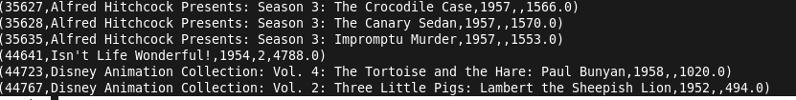

**2.** **List the movies that start with the Alpahbet A**

**FILTER movies by name matches 'A.*';**

**C:\Users\viks\Desktop\p1.png**

**O/P**

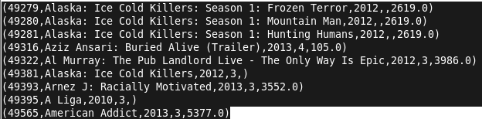

**3.** **Find the number of movies having rating more than 4.**

**FILTER movies by rating >4**

**C:\Users\viks\Desktop\p1.png**

**o/p**

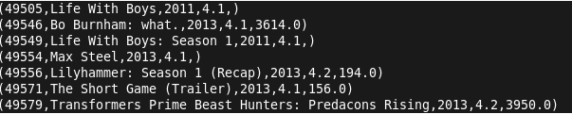

**Find the movies whose rating are between 3 and 4**

**a = FILTER movies BY rating>3.0 and rating<4.0;**

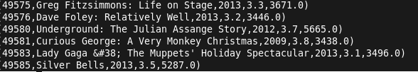

**Find the number of movies with duration more than 2 hours (7200 second).**

**movies_duration_2_hrs = FILTER movies by duration > 7200;**

**Find the list of years and number of movies released each year.**

**grouped_by_year = group movies by year;**

**count_by_year = FOREACH grouped_by_year GENERATE group, COUNT(movies);**

**Find the total number of movies in the dataset.**

**sample_10_percent = sample movies 0.1;**

**to check if it is correct or not**

**sample_group_all = GROUP sample_10_percent ALL;**

**sample_count = FOREACH sample_group_all GENERATE COUNT(sample_10_percent.$0);**

**dump sample_count;**